Web lab pat-3
Name: kakarla lakshmi prasad
Reg.no: 23MIS1102

Question1

1. Write a PHP script which decodes the following JSON string. Sample JSON code : {"Title": "The Cuckoos Calling", "Author": "Robert Galbraith", "Detail": { "Publisher": "Little Brown" }} Expected Output : Title : The Cuckoos Calling
Author : Robert Galbraith
Publisher : Little Brown2.

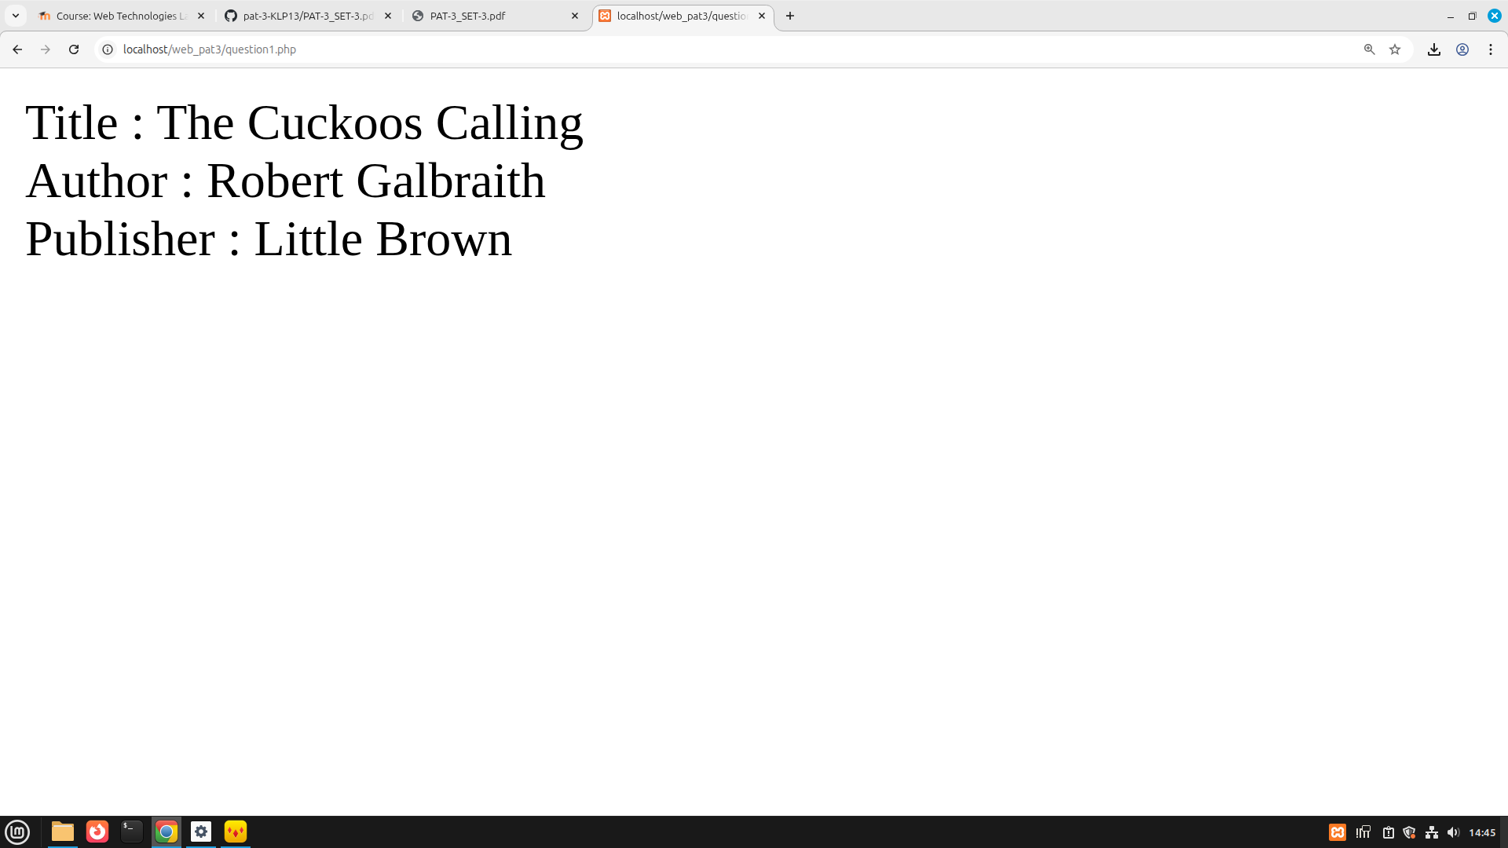

Question2

Create a PHP script that accepts a password string. The password must: • Be at least 8 characters long. • Contain at least one uppercase letter . • Contain at least one digit. • Contain at least one special character (e.g., @, #, $, %). If the password does not meet any of these conditions, throw a custom exception with a message like "Password must contain at least one uppercase letter". Handle the exception and display the error message.

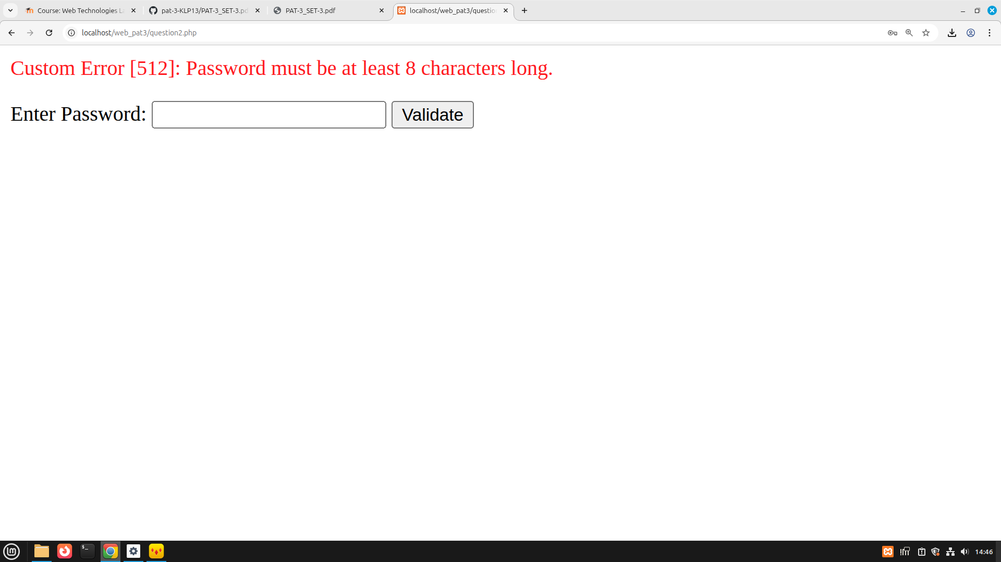

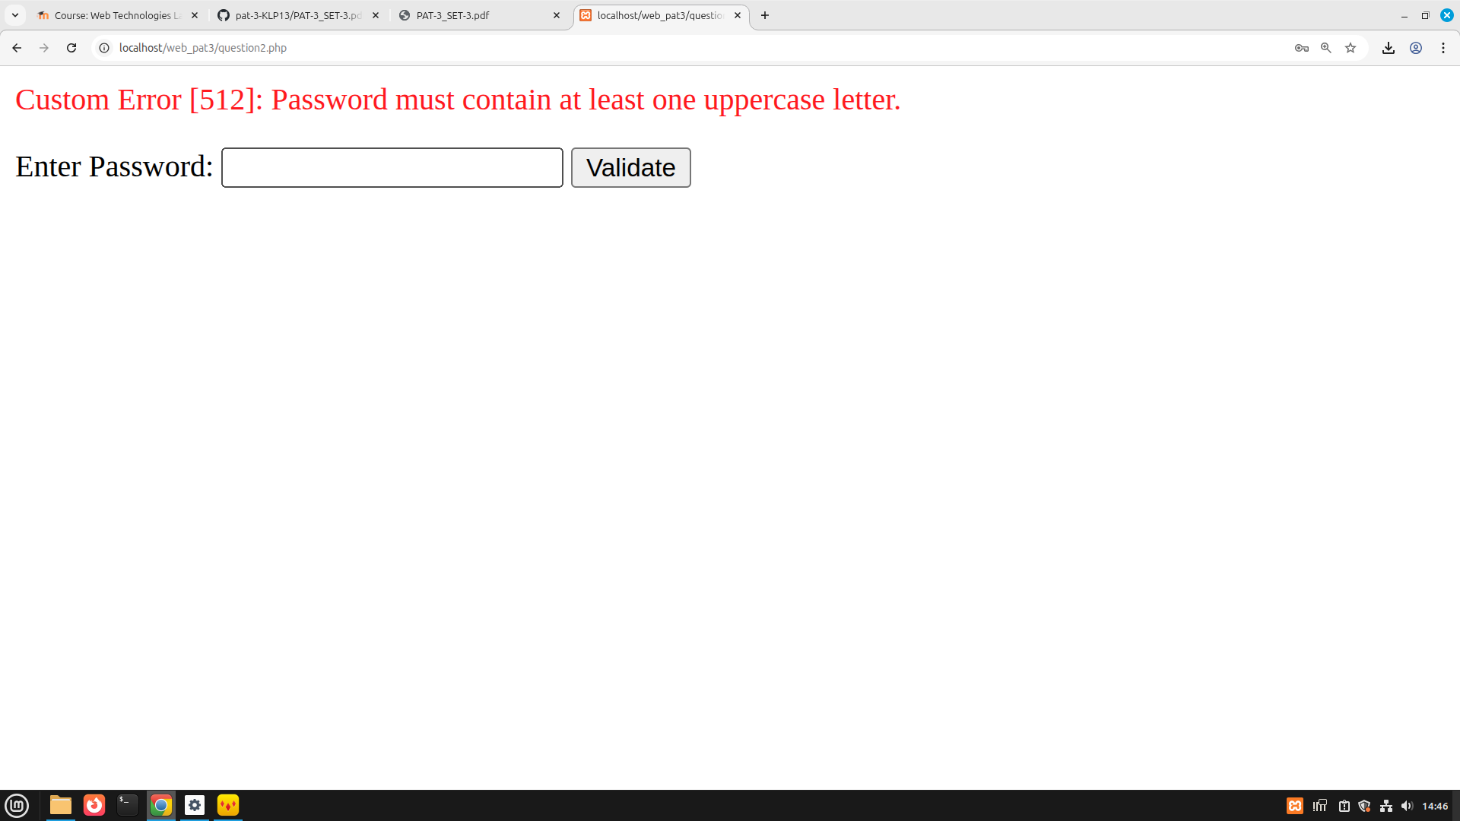

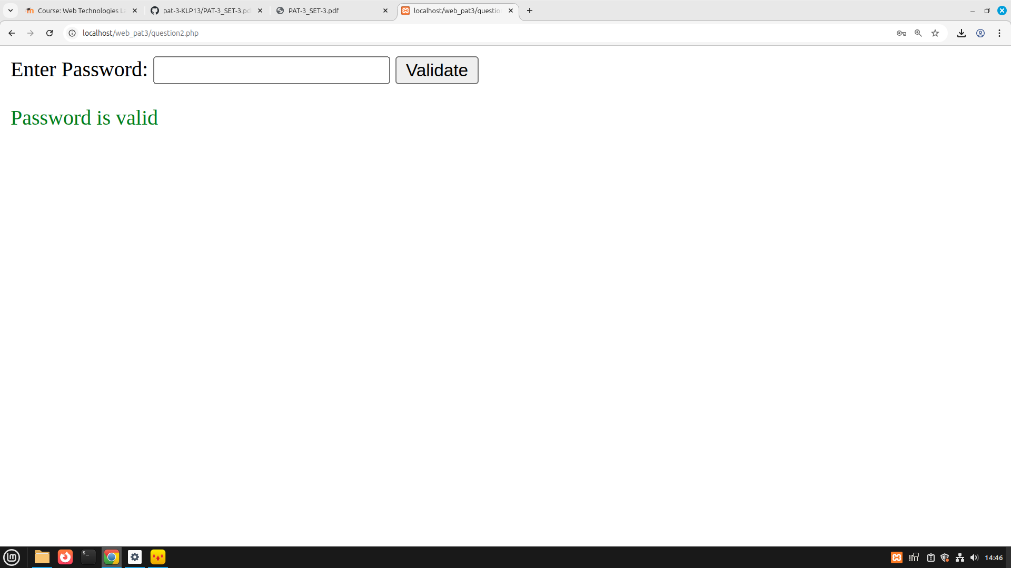

Question3:

Add a “Remember Me” option that saves the username in a cookie.

